**Lesson 1 – Information Management and**

**Critical Reading**

**Agenda:**

* Information management
* Critical reading

**Information Management**

**Information management** is a cycle of processes that support the organization's learning activities:

* identifying information needs
* acquiring information
* organizing and storing information
* distributing information
* using information

**Identifying information needs**

* What do you already know about the topic?
* How do you know it?
* How confident are you in this knowledge?
* How will you find more information about the topic?

**Acquiring information** means finding answers to our questions.

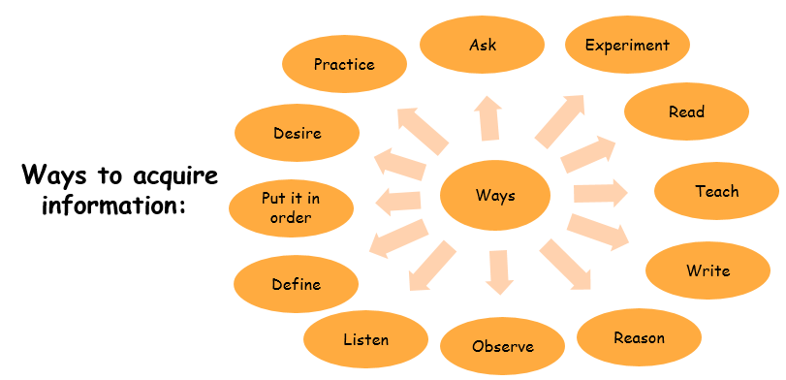

**Organizing and storing information** - *Use the* ***LATCH*** *principle*

* Location
* Alphabet
* Time
* Category
* 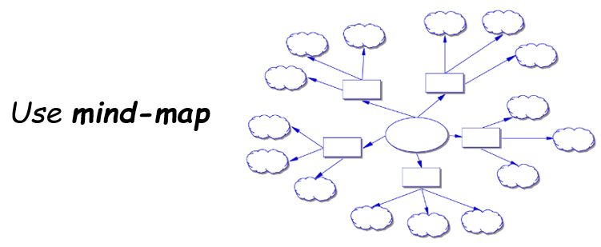Hierarchy

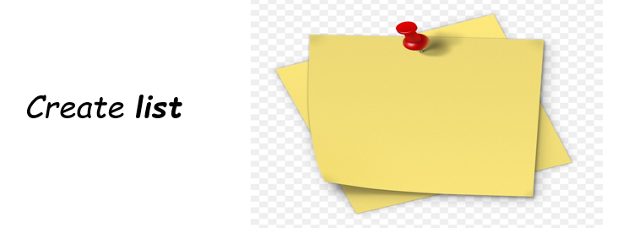

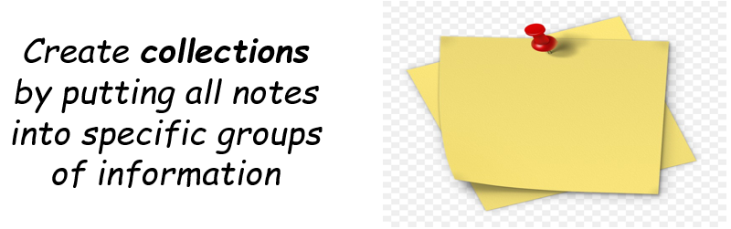

* Place priority on key information

**Distributing information**

* Answer to your trainers’ questions
* Answer to your classmates’ questions
* Explain the lessons to your friends
* Teach juniors what you have learned

**Using information**

Students can use the information they have to improve their study, schoolwork, class activities, and learning process.

**Critical Reading**

**Critical reading** is a process of analysing, interpreting, and sometimes evaluating the text.

To apply critical reading, use the **SQ4R Method:**

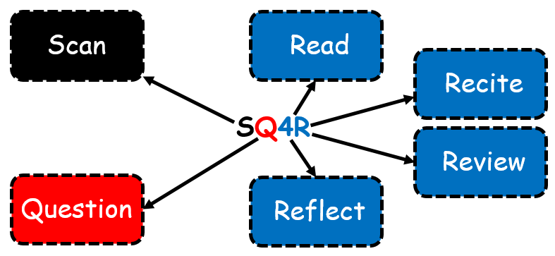

**Scan** the materials you are going to read:

* Table of contents
* Introduction or preface
* Title
* Headings
* Graphics

**Formulate questions** about title and headings:

* What
* Who
* When? Where?
* Why? How?

**R1: Read**

Read and look for the answers to your questions, write down the answers, make note of the main idea, and make the summary.

**R2: Recite**

Look up and briefly recite aloud what the section you read was about.

**R3: Review**

Review your questions and answers and make a cluster of the main ideas.

**R4: Reflect**

Go beyond what you understand from your reading and think deeply about it.

**Ask the following questions to apply critical reading:**

* Who is the author?
* Who is the audience?
* When was it written?
* What is the main claim of the reading?
* Is the evidence fact, opinion, or personal experience?
* Is the evidence accurate?
* Are key terms defined?
* Does the logic flow?
* Is the reading biased?
* What are the limitations of the reading?